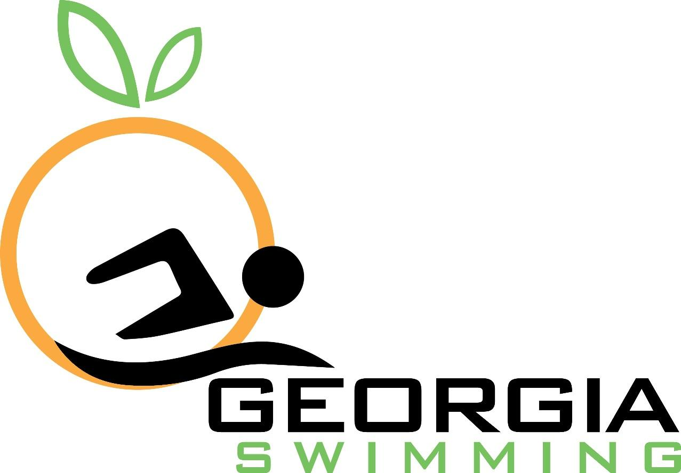

2019 Bill Young Award Nomination

Nomination Period Opens: January 21, 2020
Nomination Deadline: March 15, 2020

The Bill Young Award is presented annually to a swimmer who will graduate from high school in the spring of this competitive swim year. The Georgia Swimming Board of Directors will evaluate all nominees for this award based partially on swimming achievements and of equal importance, participation in and recognized achieved for non-swimming activities, such as scholarship and school-related activities, church and community service, etc. This award will be presented at LCM Senior State meet.

The criteria for nominations for the Bill Young Award are as follows:
- The swimmer must graduate from high school during the school year of the current season.
- The swimmer must have actively participated in and must have been a registered member of Georgia Swimming Inc. for the past two years.

Please complete this form and return to Megan Kingsley at admin@gaswim.org

Nominator Contact Information
Full Name
Phone
Email

Nominee Contact Information
Nominee Full Name
USAS Club
USAS Registration Number
Birthdate
Phone
Coach
Coach’s Email

To be eligible, the nominee must graduate from high school during the school year of the current season. Please complete the following information regarding graduation from high school.

High School Information
School Name
Address
Phone
Expected Graduation Date

The nominee must have actively participated in and must have been a registered member of Georgia Swimming Inc. over the past two years. Please list at least one SC and one LC meet in which the swimmer represented Georgia Swimming during the last two years. Include the name, date, location of the meet, event swum and the time obtained. These items are available from the SWIMS database on the USA Swimming website.

Below, please list any participation in and recognized achievements for non-swimming activities, such as scholarship and school-related activities, church and community service, etc.

